Testing the Capacitor Board

Servicing a SuperDARN Transceiver  
Step 6

Content

1. Introduction 3

2. Instructions 3

3. Conclusion 4

# Introduction

This document provides work instructions for testing the Capacitor Board in a SuperDARN transceiver box. Before attempting to implement these instructions, be sure to complete all the preceding steps in the procedure for Servicing a SuperDARN Transceiver.

# Instructions

Following are the step-by-step instructions for testing the Capacitor Board. In the case of unforeseen problems occurring, apply electronic fault-finding techniques. Refer to *Figure 1* for component and connection locations.

1. Connect the Phoenix connector between the Power Distribution Board (**J3**) and the Capacitor Board (**J1**). Make sure that the discharge resistor is connected at **J2** on the Capacitor Board.
2. Power on and apply the 3.3 V signal to the STC. When 3.3 V is applied, the 50 V will enable, and **D3** on the Capacitor Board will light up. Disconnect the 3.3 V signal and **D3** should start to dim. After approximately 15 to 20 seconds, **D3** should be completely off.
3. If the Capacitor Board does not discharge, check the MOSFET, **Q2**. Also check that the controller has shut off the 50 V supply. Before doing the above also try power cycling it to make sure or check the resistor.
4. Check that the Front Panel Board does not brown out and reset. If this happens, there is a problem with **C9** and **C10** on the front panel or with **C10** and **C11**. They are either not large enough or not connected properly; check this with a continuity test.
5. If all is well, disconnect the 50 V supply to the capacitor board again and power off.

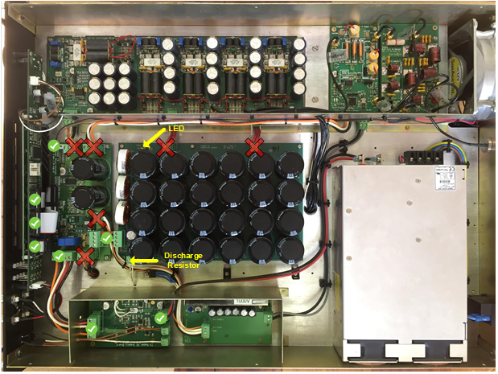

Figure . Important connections and components on the Capacitor Board.

# Conclusion

This concludes the work instructions for testing the Capacitor Board of a SuperDARN transceiver box. The next step in the procedure for Servicing a SuperDARN Transceiver is to test the High-Power Switch.